**Key Performance Indicators (KPIs) Overview:**

The dashboard prominently features several pivotal Key Performance Indicators (KPIs) that collectively offer a comprehensive snapshot of Blinkit's operational efficacy and market performance.

* **Total Sales: $1.20M** This figure represents the aggregate revenue generated, serving as the paramount indicator of the enterprise's overall financial health and market penetration. While the current magnitude is indicative of robust activity, a more profound understanding necessitates an analysis of its temporal trajectory, which the "Outlet Establishment" trend offers, allowing for the identification of growth patterns, periods of stagnation, or decline.
* **Average Sales: $141** This metric quantifies the average transactional value, providing crucial insights into customer purchasing behavior and spending propensities per order. Its true significance is unlocked when benchmarked against historical performance data or industry-specific averages, enabling a nuanced assessment of pricing strategies, customer segmentation, and market positioning.
* **Number of Items: 8523** This particular KPI, depending on its precise definition within the business context, could either signify the average quantity of distinct items comprising each customer order, thereby reflecting basket size and cross-selling effectiveness, or alternatively, the average inventory breadth maintained across the entire network of outlets. Clarification on its exact derivation is essential for precise interpretation and actionable insights into inventory management or customer purchasing habits.
* **Average Rating: 3.9** As a direct measure of customer satisfaction, this average rating is a critical barometer of service quality and customer loyalty. While a score of 3.9 (presumably out of 5) suggests a commendable level of satisfaction, it simultaneously highlights an opportunity for enhancement. Continuous monitoring and strategic initiatives aimed at elevating this metric towards a perfect score are imperative for fostering enduring customer relationships and bolstering brand reputation in a competitive landscape.

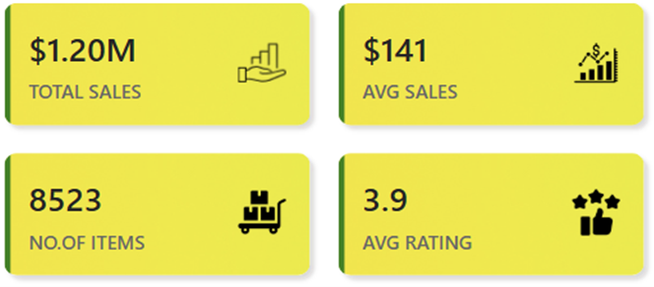

The dashboard incorporates an innovative use of the slicer mechanism, enabling it to function as a **dynamic KPI selector**. By engaging with this slicer and choosing a specific Key Performance Indicator, the underlying data visualizations and metrics displayed throughout the dashboard are **instantly reconfigured** to present insights directly related to the selected KPI. This approach significantly enhances analytical agility, allowing users to pivot effortlessly between different core performance measures and gain targeted insights into their respective contributions and trends.



**1. Total Sales & Average Sales by FAT Content (Donut Chart)**

* **Visual Type:** Donut Chart with superimposed data labels.
* **Insight:** This visualization disaggregates total sales and average transaction values based on the "FAT Content" classification of products (Low Fat versus Regular).
  + **Total Sales Distribution:** "Regular" category products dominate the revenue landscape, accounting for $775K (64%) of total sales, nearly doubling the contribution of "Low Fat" items at $425K (35%). This pattern suggests a prevailing consumer preference for, or a higher volume of sales in, regular-fat products.
  + **Average Sales Consistency:** Notably, the average sales figures exhibit remarkable proximity across both categories ($141 for Low Fat vs. $142 for Regular). This indicates that while the overall sales volume for regular items is substantially higher, the typical customer expenditure per transaction is largely consistent irrespective of the fat content of items purchased.
* **Analysis:** The data underscores a significant market leaning towards regular-fat products. However, the consistent average transaction value implies that pricing strategies or basket composition do not drastically differ between the two categories at the individual transaction level.

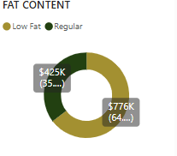

**2. Item Type Performance (Stacked Bar Chart)**

* **Visual Type:** Stacked Bar Chart.
* **Insight:** This chart delineates sales performance in dollar terms across various "Item Types."
  + **Leading Categories:** "Fruits and Vegetables" emerge as the strongest category with $0.18M in sales, closely followed by "Snack Food" ($0.16M), "Household" ($0.14M), "Frozen Food" ($0.12M), and "Dairy" ($0.10M).
  + **Underperforming Categories:** Categories such as "Seafood," "Breakfast," and "Starchy..." exhibit comparatively lower sales volumes, though their precise values are truncated in the visual.
* **Analysis:** The dominance of fresh produce and staple grocery items is typical for a quick-commerce or grocery delivery service, reflecting core consumer needs. The strong performance of "Snack Food" also highlights impulse or convenience-driven purchases.

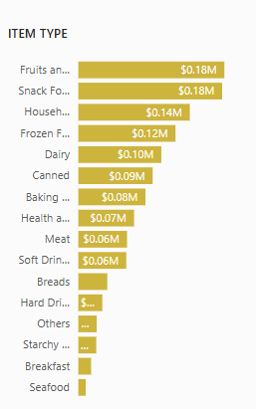

**3. FAT Content Sales by Outlet Tier (Clustered Bar Chart)**

* **Visual Type:** Clustered Bar Chart.
* **Insight:** This visualization provides a granular breakdown of sales by "FAT Content" across distinct "Outlet Tiers" (Tier 1, Tier 2, Tier 3).
  + **Tier 3:** Demonstrates the highest overall sales volume at $0.48M, with a notable contribution from "Low Fat" items ($0.31M) exceeding "Regular" items ($0.17M).
  + **Tier 2:** Accounts for $0.39M in total sales, with "Low Fat" ($0.25M) again outpacing "Regular" ($0.14M).
  + **Tier 1:** Registers $0.34M in total sales, but uniquely, "Regular" items ($0.22M) significantly outweigh "Low Fat" items ($0.12M).
* **Analysis:** This chart uncovers compelling variations in consumer preferences and purchasing patterns across different geographical or demographic segments represented by the outlet tiers. Tier 3 outlets, while generating the highest overall sales, exhibit a distinct inclination towards low-fat products, contrasting sharply with Tier 1 outlets where regular-fat products are more prevalent**.**

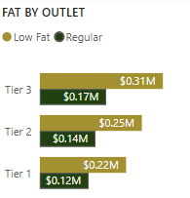

**4. Outlet Establishment & Sales Trend (Line Chart)**

* **Visual Type:** Line Chart with data points and shaded area.
* **Insight:** This chart illustrates the temporal evolution of sales performance, spanning from 2010 to 2020, likely correlated with the establishment or operational maturation of outlets.
  + **Trend:** Sales commenced modestly at $75K in 2010, demonstrating a consistent upward trajectory to peak at $265K around 2018-2019. However, a noticeable deceleration and subsequent decline occurred, with sales dropping to $131K by 2020.
* **Analysis:** The sustained growth over nearly a decade signifies successful market penetration and expansion efforts. The subsequent downturn in 2020, however, represents a critical inflection point. This decline could be attributable to various factors such as intensified competitive pressures, market saturation, shifts in macroeconomic conditions, or potentially the early impacts of the global pandemic (given the dataset's cutoff at 2020).

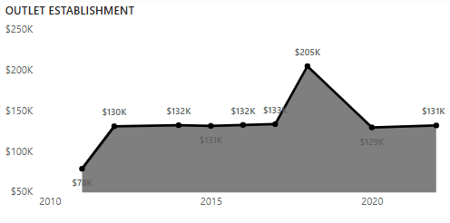

**5. Sales by Outlet Size (Donut Chart)**

* **Visual Type:** Donut Chart with superimposed data labels.
* **Insight:** This visualization segments total sales contribution by "Outlet Size" (Medium, High, Small).
  + **Dominant Contributors:** "Medium" sized outlets account for the largest share at $508K (42%), followed closely by "High" sized outlets at $445K (37.01%).
  + **Lesser Contribution:** "Small" outlets contribute a significantly smaller proportion at $249K (20.72%).
* **Analysis:** The data clearly indicates that Medium and High-sized outlets are the primary drivers of revenue, collectively generating nearly 80% of total sales. This suggests that larger operational footprints correlate directly with higher sales volumes. Small outlets, while contributing, are not central to the overall sales strategy.

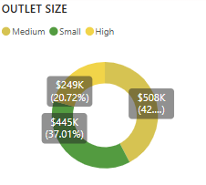

**6. Outlet Location Distribution (Funnel Chart)**

* **Visual Type:** Funnel Chart with percentage axis (though values are absolute counts).
* **Insight:** This chart depicts the distribution of "Outlet Locations" across the defined "Tiers" (Tier 1, Tier 2, Tier 3).
  + **Distribution:** Tier 3 locations are the most numerous (472.12K), followed by Tier 2 (393.15K), and Tier 1 (336.40K). (Note: The numerical labels appear to represent counts in thousands, which is a slight inconsistency with the "100%" Y-axis label, suggesting a distribution rather than a summation).
* **Analysis:** The observed distribution, with Tier 3 locations being the most prevalent, aligns coherently with the sales performance indicated in the "FAT By Outlet" chart, where Tier 3 outlets also exhibited the highest sales contribution. This suggests a deliberate and effective strategy of concentrating outlets in high-performing geographical or demographic areas

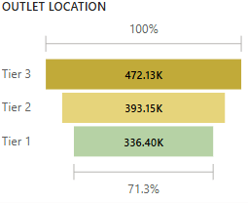

**7. Outlet Type Performance (Table)**

* **Visual Type:** Tabular representation.
* **Insight:** This table provides granular performance metrics for various "Outlet Types," including "Grocery Store," "Supermarket Type1," "Supermarket Type2," and "Supermarket Type3."
  + **Grocery Store Dominance:** "Grocery Stores" demonstrably outperform all other types, leading in Total Sales ($788K), Number of Items sold (152K), Average Sales ($140), Average Rating (4), and Item Visibility (0.10).
  + **Supermarket Performance:** "Supermarket Type1" exhibits respectable sales ($557K) and item volume (577), with "Supermarket Type2" and "Supermarket Type3" showing comparatively lower, yet consistent, performance across Average Sales and Average Rating. The Average Sales and Average Rating metrics show remarkable consistency across all supermarket types, hovering around $140-$141 and 4 respectively.
* **Analysis:** "Grocery Stores" are unequivocally the powerhouse of the operation, excelling across all performance dimensions. Their superior "Item Visibility" may be a contributing factor to their higher sales volume. The consistency in Average Sales and Average Rating across various supermarket formats is a strong indicator of standardized operational quality and customer experience.

